Git Basic commands
- git init --- create a empty git repository
- git status --- To check the status
- git add . --- adds all the files to staging area
- git rm –cached filename --- it removes that file from the staging area
- git commit -m “message " ---- record the changes to the local repository
- git log --- shows the history of the comments
git log – oneline --- shows in one line
- git remote add <name> <URL> --- it binds the local repository with remote repository
- git remote – v --- it shows the binding
- git branch _M main ---- going to map our local branch with remote main branch
- git pull –allow-unrelated-histories ---- help to pull all the changes from the remote repository to local repository
- git pull origin main –-- help to pull all the changes from the remote repository to local repository
- git push origin main – help to push all the changes from our local repository to the remote repository
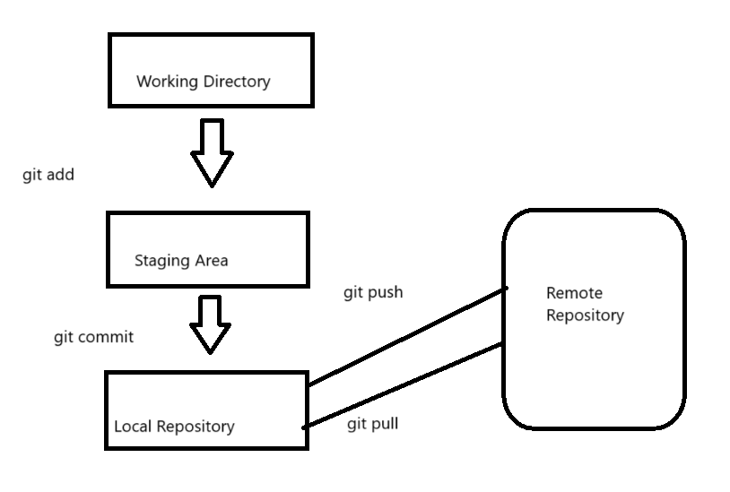
- git clone <URL> ---- to download/copy git repository
- git diff ---- help to track the uncommitted changes on a particular file
- git revert -n <commit id> ---- to undo the changes on the existing commit
Revert -That means return to previous version of a file or project, instead of keeping recent changes.
- git reset –hard <commit id> --- helps to undo the changes to the specific point
- git config ---- to set configuration values on a global or local project level
- git show ---- basically gives us the metadata and content changes
- git branch --- lists the branch
- git branch <name> --- create new branch
- git branch -d <name> ---- delete the branch
- git checkout -b <name> -- it create new branch and also currently pointing on a new branch
if we create a file in and add and commit it will save in this branch only if we go to main branch, it will not have that file
- git merge <branch name> --- it helps to changes into our main branch

